The King’s C of E Primary Academy
Living Well Together
  Growing confident and aspirational children who believe in themselves and contribute positively to their community and the wider world.  Kindness Friendship Faith | 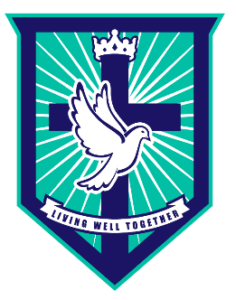
Attenborough Class Newsletter September 10th 2024

Dear families,

The children have had a wonderful first week in school. We would like to thank you for helping your child prepare for this school year. We are so impressed by how they have started at big school. They have spent the first few days exploring both our indoor and outdoor classrooms and getting to know each other. We can tell already that we are going to have a great year with them all!
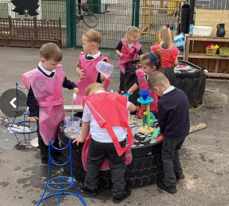
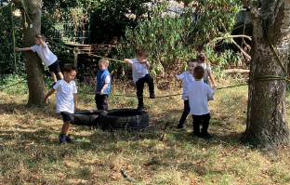
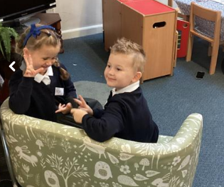

Learning in School

This half term we will be learning all about ‘Marvellous me’. We will work hard at becoming kind, confident and independent members of our class. We will make new friends, learn to take turns and work hard to follow the rules and routines of our classroom. Along with the whole school, we will cover specific themes of ‘Get HeartSmart’ and exploring one of our Christian Values ‘Kindness’.


As part of becoming more independent, we will be learning how to take off our own jumper/cardigan and how to do our zips. Please ensure all belongings, including lunch boxes and water bottles, are clearly labelled with your child’s name. We will be developing our fine motor skills ready for writing by taking part in daily dough disco’s and funky finger activities. Once the children are settled, we will begin our daily Read, Write, Inc lessons and group Maths activities.

As part of or ‘Marvellous Me’ topic we will be discussing the things that make us unique, talking about similarities and differences and learning about ways to keep us healthy. Our daily routine includes lots of physical activity outdoors, therefore we will not be doing weekly PE lessons until after October half term. I will send a reminder out closer to the time to let you know about PE kits, we are very lucky as we have a coach!

Please don’t hesitate to see a member of the Foundation Team if you have any questions about upcoming events.

September 4-6 | Settling in/Starting School | Class Dojo information sent
September 9-13 | Our Class/David Attenborough | Individual child’s photo (13.09.24)
September 16-20 | What happens at school?  Once there were giants | Read, Write Inc begins  White Rose Maths begins
September 23-27 | How am I unique?  How to catch a star
September/October 30-4 | Who lives in my house?  One Family | 1st & 3rd October – Parents Evening
October 7-11 | How have we changed?  Detective Dog Nell
October 14-18 | Noah’s Ark  What happens during Autumn?  What is Harvest? | Harvest Festival 17th October at 10am.

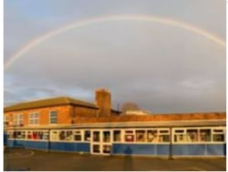
Please do not hesitate to let us know any concerns or ask us any questions. The easiest way to do this is through the school organisers but you can also email contactus@wmg.snmat.org.uk if you prefer. We are really looking forward to a great year teaching your child - let’s make this their best year ever!

Many thanks and best wishes to you all!

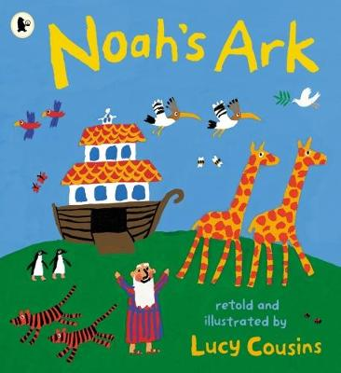
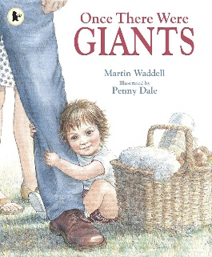
Reading Recommendations:


