The King’s C of E Primary Academy
Living Well Together
  Growing confident and aspirational children who believe in themselves and contribute positively to their community and the wider world.  Kindness Friendship Faith | 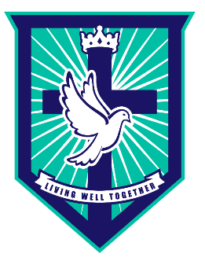
Owl’s Class Newsletter September 15th 2023

Dear families,
The children have had a wonderful first week in school. We would like to thank you for helping your child prepare for this school year. We are so impressed by how they have started at big school. They have spent the first few days exploring both our indoor and outdoor classrooms and getting to know each other. We can tell already that we are going to have a great year with them all!

Learning in School

This half term we will be learning all about ‘Marvellous me’. We will work hard at becoming kind, confident and independent members of our class. We will make new friends, learn to take turns and work hard to follow the rules and routines of our classroom. Along with the whole school, we will cover specific themes of ‘Get HeartSmart’ and exploring one of our Christian Values ‘Kindness’.


As part of becoming more independent, we will be learning how to take off our own jumper/cardigan and how to do our zips. Please ensure all belongings, including lunch boxes and water bottles, are clearly labelled with your child’s name. We will be developing our fine motor skills ready for writing by taking part in daily dough disco’s and funky finger activities. Once the children are settled, we will begin our daily Read, Write, Inc lessons and group Maths activities.

As part of or ‘Marvellous Me’ topic we will be discussing the things that make us unique, talking about similarities and differences and learning about ways to keep us healthy. Our daily routine includes lots of physical activity outdoors, therefore we will not be doing weekly PE lessons until after Christmas.

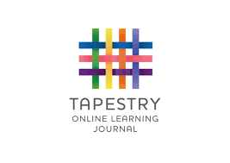
Please keep an eye on your emails as we will be sending you a link to activate your child’s Tapestry account in the next few weeks. This is an online learning platform where we can share what your child’s ‘Wow moments’ from school with you. Likewise, you are able to upload photos and comments about what your child has achieved at home.

 | Topic Area | Other Important Events
September 4-8 | Settling in/Starting School | Class Dojo information sent
September 11-15 | Our Class/Owl Babies | School Photos (15.09.23)
September 18-22 | What happens at school?  Once there were giants | Read, Write Inc begins  White Rose Maths begins
September 25-30 | How am I unique?  How to catch a star
October 2-6 | Who lives in my house?  One Family
October 9-13 | How have we changed?  Detective Dog Nell
October 16-20 | Noah’s Ark  What happens during Autumn? | Visit to Newark Library (16.09.23)  Parents Evening

This half term we are hoping to hold workshop for parents to come in and join in with story time. There will also be other workshops such as Read Write Inc, Tapestry and Maths. Check Parentmail and Tapestry for more information on this.

We are looking forward to working together to support your child to reach their potential.

Please do not hesitate to come and see us at the door or call us.
The Foundation Team.

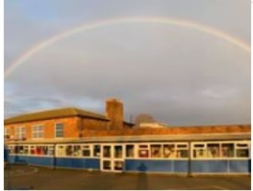
Please do not hesitate to let us know any concerns or ask us any questions. The easiest way to do this is through the school organisers but you can also email contactus@wmg.snmat.org.uk if you prefer. We are really looking forward to a great year teaching your child - let’s make this their best year ever!

Many thanks and best wishes to you all!

