What an exciting half term!
Hansel & Gretel - Bethan Woollvin
Science– Who are these famous explorers? Where did they go? What did they do?
Earth and Space
Afro Pop
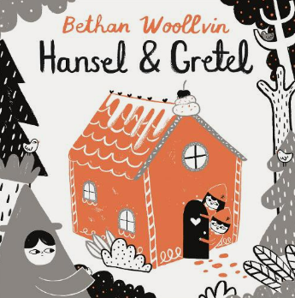
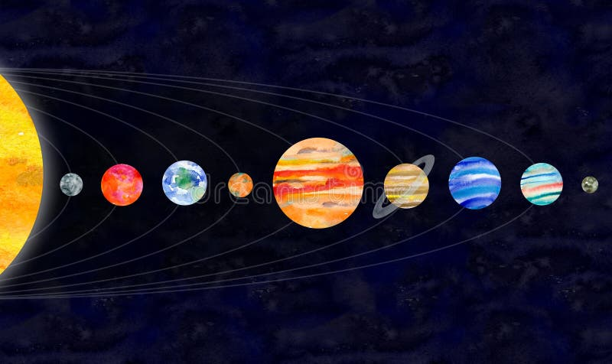
What are we learning in Key Stage 1?
English -
Hansel and Gretel
Music - Hands, Feet, Heart
Afro Pop

Key Vocab
Love
Care
Touch
Un/Comfortable
Permission
Consent
Truth/Lies
Self-esteem
Self-confidence
Preference
Decision
Unique
Patience
Reward
Self care
Well-being
Reflect
History - Homes
PE -
Multi-Skills
Computing - E-Safety
Space
Moon
Star
Mars
Venus
Earth
Mercury
Jupiter
Saturn
Neptune

HeartSmart - Don’t Forget to Let Love In!

Key Vocab
Narrative
Adjective
Capital letter
Full stop
Fred Fingers
Finger space
Conjunction
Key Vocab
Pulse
Verse
Chorus
Rhythm
Chorus
Ending
Body Percussion
Key Vocab
Saxon
Norman thatched
Wattle and daub
period
Reign
Tudor
Victorian
Beams

Sash windows

brick

Terraced

Key Vocab
Personal information
Sharing
Permission
Report
Trust
Respect
Key Vocab
Run
Jump
Throw
Catch
Track
Receive
Underarm
Bounce
Traditional Tales


Key Vocab: Pop Art
Printing
Gallery
shape, pattern, colour,
media,
simple line picture

Art -
Present
Past
Pop Art

Andy Warhol - Pop Art & Printing

- habitats

Year 1 and 2
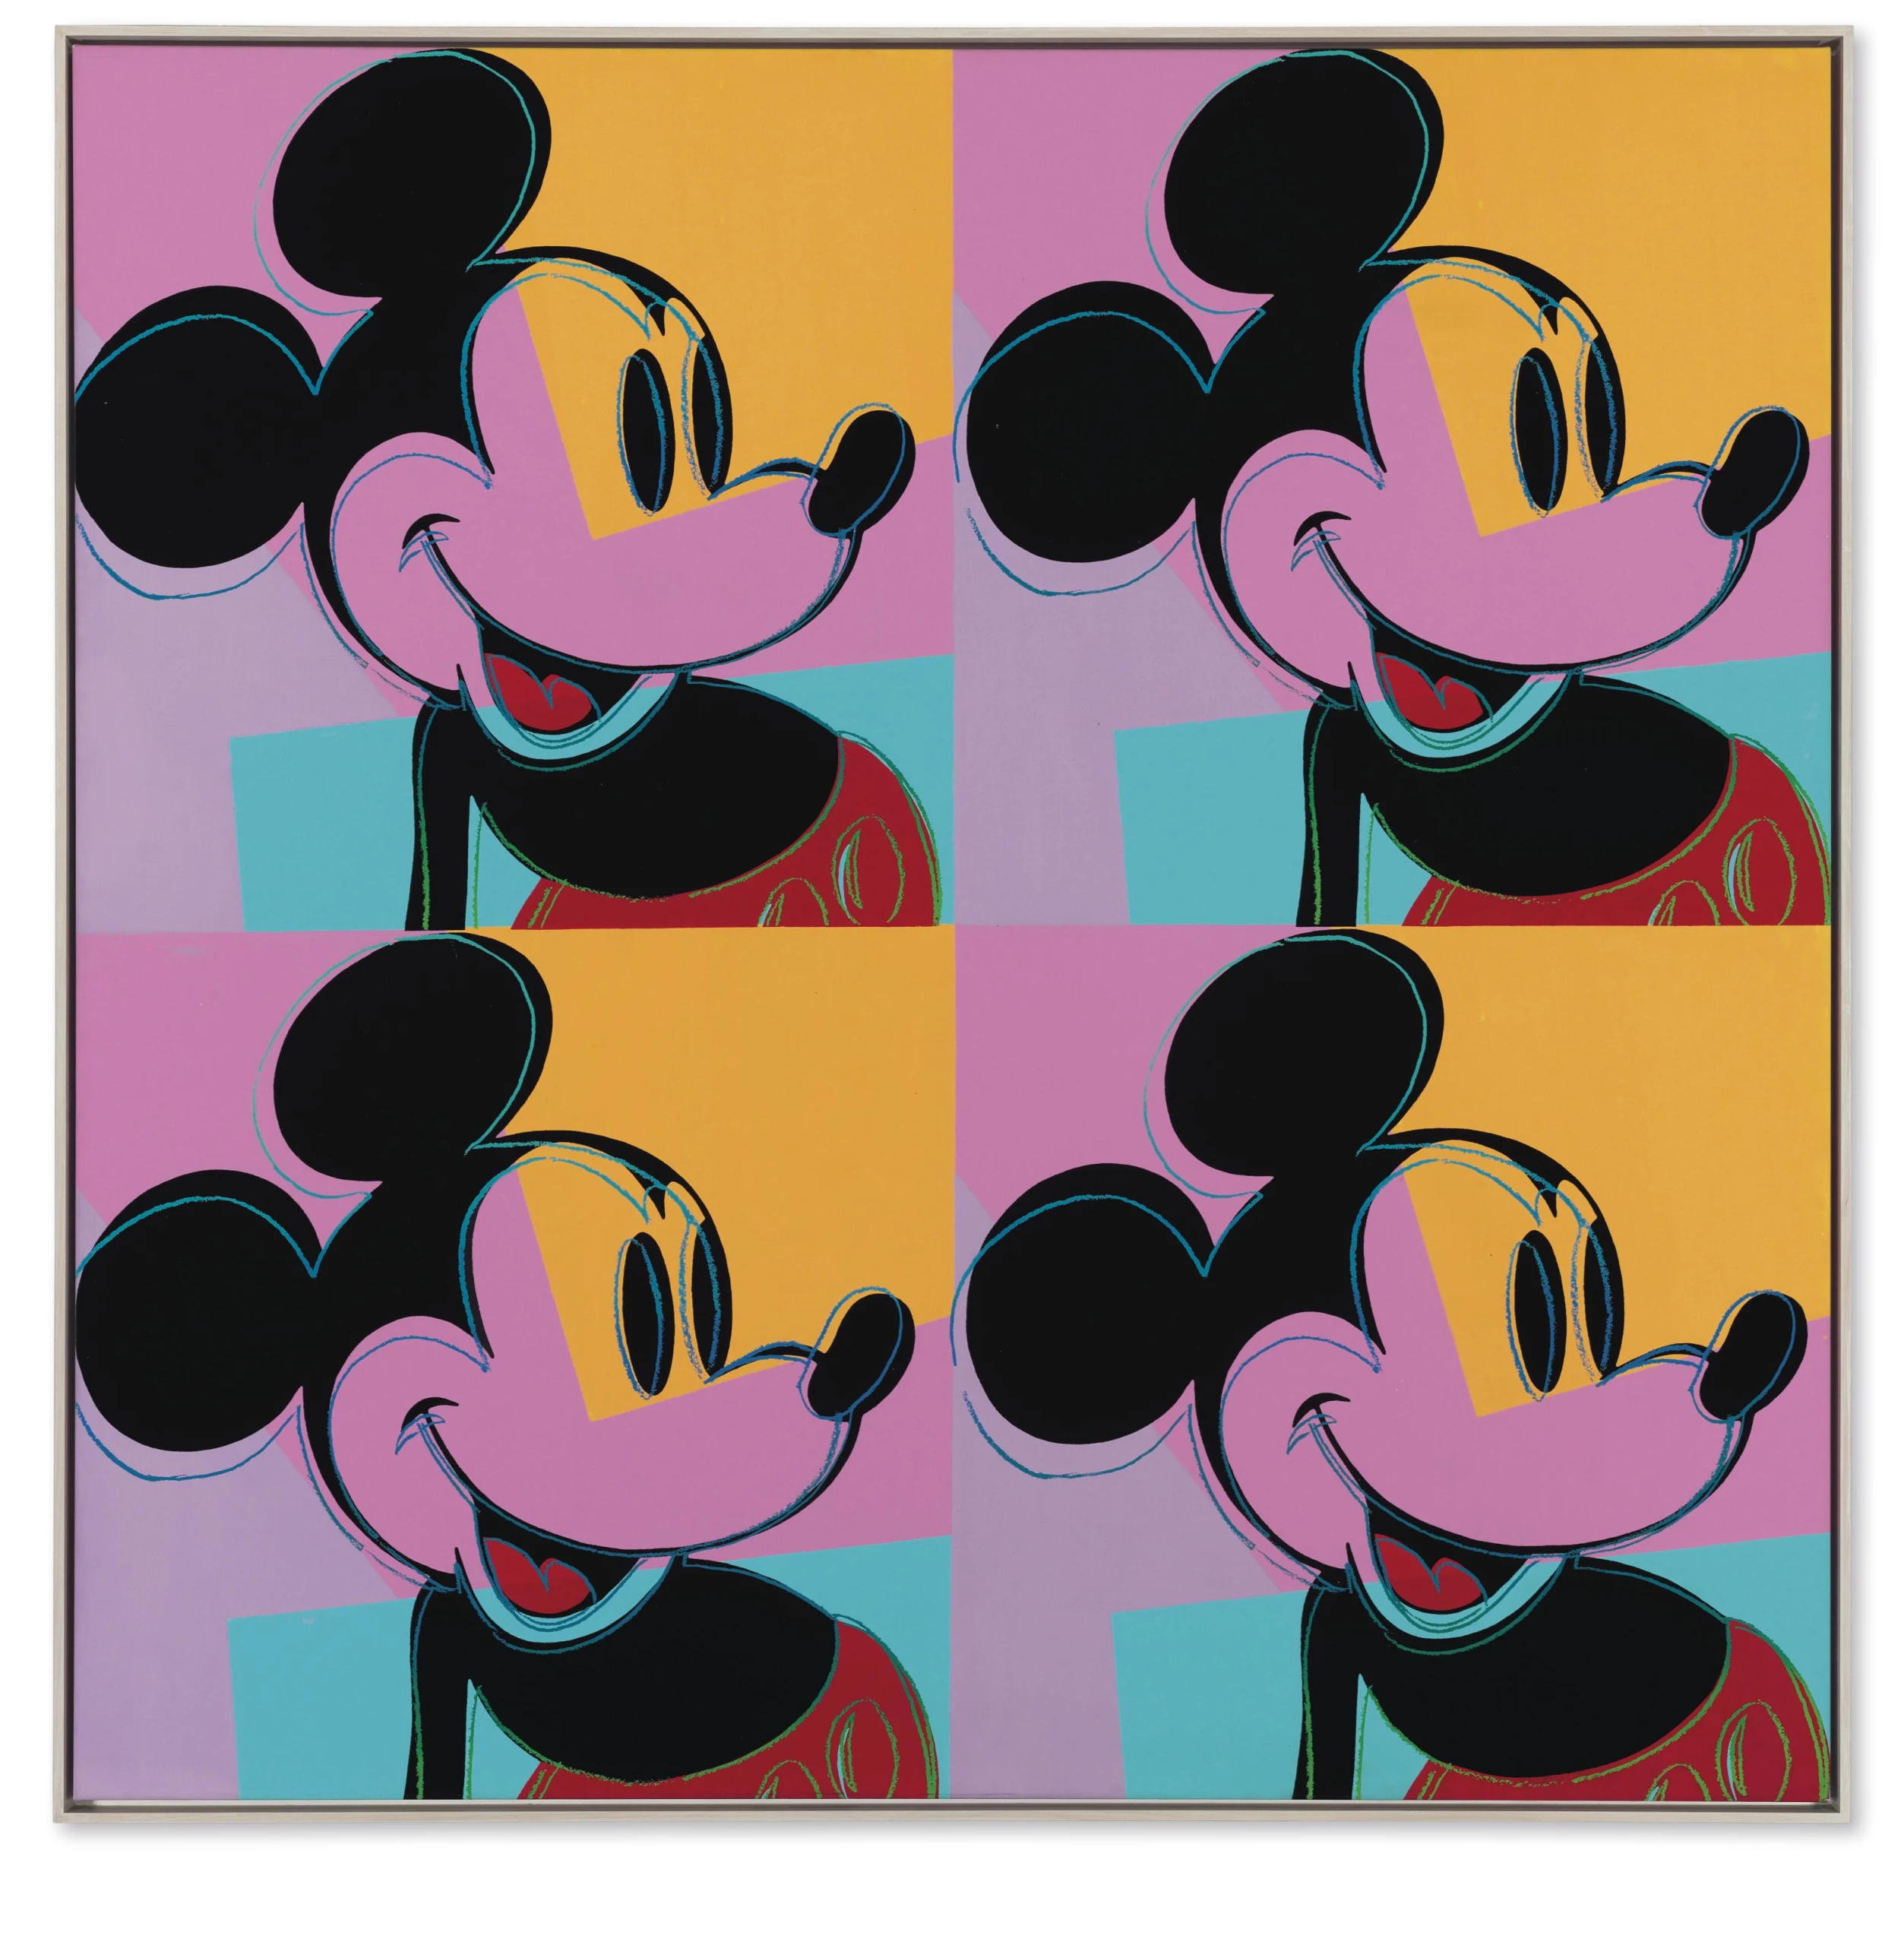
Autumn 1

You can complete your chosen tasks in any order and you are expected to achieve more than 100 points. There will be a prize draw for all children who achieve this.
Homework can be evidenced in different ways such as written work, a talk to the class or photographs.
There will be points awarded for achievement.
The deadline for handing in your homework is Wednesday 18th October.
Homework menu | Points achieved
Maths  Practice your numbers – Log onto Numbots 3 times a week and practise your number fluency.  English  Read at home at least 5 times a week – planner signed for each read.  Practice weekly spellings and show increased spelling competence.  Write a story based on Hansel and Gretel or going into Space.  Science  Design and make your own solar system using any media you wish.  Art  Create a picture in the style of Andy Warhol using any media you wish.  History  Build a home using any media of your choice. | 10 points per time logged on  10 points per week achieved  10 points per week achieved  20 points  20 points  20 points  15 points
Hello and Welcome to Year 1 & 2,
We hope you all had a wonderful Summer holiday and are ready and raring to go for the new term at school. Mrs Shore, Mrs Tregunno and Mrs Jones are really looking forward to welcoming you all back and getting to know each and every one of you. We have lots of amazing things planned for you and we can’t wait to share all these wonderful experiences with you. In Year 1 and 2 there are some key dates, expectations and information that we would like to share with you.
Our TAs are Mrs Edlin, Miss Oxberry, Miss Jermyn, and Mrs Germanis and are also looking forward to the year ahead with Year 1 & 2.

Key Information
PE days - Magpies - Monday
Sparrows - Friday
Robins - Friday
All children must bring in full PE kit (white top and navy blue/black joggers/shorts and a change of shoes no jewellery) on these days.
All pupils need to be in school PE kit with no football kits. All children need a water bottle and to bring in their diary every day. Please make sure they put their reading book and diary in their class box each day to enable us to be able to read with
No mobile phones are permitted in school.

Key Dates
15th September- Individual school photos
October - Black History Month
2nd October - Mental Health Week
16th and 18th October - Parents evening
19th October - Harvest festival at Church, 10am

