Foundation and key stage 1
Uniform

Navy sweatshirt, white polo shirt, grey trousers or shorts, black smart shoes.
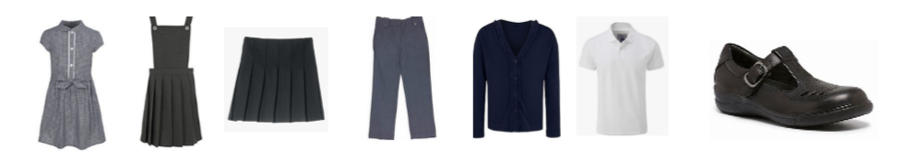
Navy sweatshirt or cardigan, white polo shirt, grey skirt, trousers or pinafore dress, Navy gingham dress (summer), black smart shoes
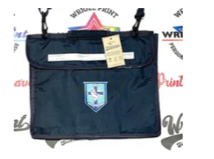


Key stage 2
Navy V-neck jumper, White shirt and school tie, grey trousers or shorts, Black smart shoes.
Navy V- neck jumper or cardigan, White shirt and school tie, grey skirt, trousers or pinafore dress, Navy gingham dress (summer), Smart black shoes


