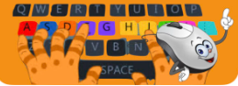
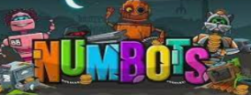

Music
South African Styles
Pulse, Rhythm, Pitch
Tempo, Texture
Art – Antoni Gaudi
Mosaics

Computing
Mouse and Keyboard skills
Mouse Trackpad Cursor Home row

Kindness

Who is Antoni Gaudi?
What style of art did Gaudi focus on?
How can we create art inspired by this artist?
Architect Artist Mosaic Style
Technique colour pattern
Science – Living things and their habitats
History – Toys of the past

Key Vocabulary:
Old
New
Same/different
Material
Past
Present
Future
Timeline
Generation
Key Vocabulary:
Living
Non – living
Habitat
Organism
Plants
Animals
Micro-habitat
Environment
Wildlife
Minibeasts
Decomposers
Invertebrates
Food chain
Herbivore
Omnivore
Carnivore

What are the differences between living and non-living?

What is a habitat?

How are habitats different?

What do you think would happen if we didn’t have mini beasts?

What are our toys like today?
What are other people’s toys like?
How can we tell these toys are old?
What were our grandparents’ toys like and how do we know?
Who played with these toys a long time ago?
How can we set up a Toy Museum?

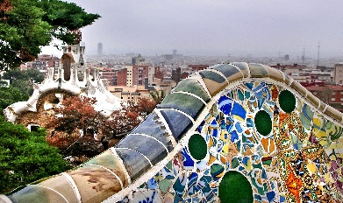

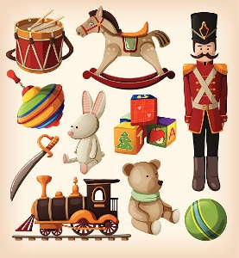
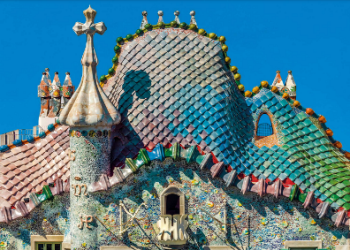

PE Year 1– Gymnastics

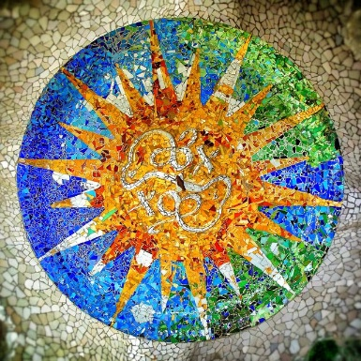
Balance Back support
Sequence Front support
Tuck Pike Straddle Star

Agility Balance Co-ordination

RE – Who made the world?

Creation Thankfulness
Universe Sustainer
Provider Harvest

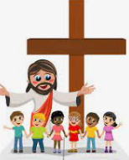

PE Year 2 – Multi-skills

Get
Heartsmart

HeartSmart these famous explorers? Where did they go? What did they do?

