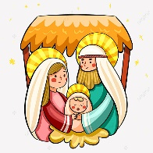
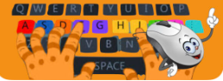


Kindness
DT -
Levers & Sliders
Music
Nativity

Computing
Y1 - Music Creation
Y2 - Digital Art

How do pictures move using mechanisms?
How can we make pictures move by using mechanisms?
How can we evaluate the effectiveness of a mechanism?

Mechanism, model, lever, slider, assemble, design, template, design criteria, test, evaluate, up/down/forwards/backwards/
horizontal/vertical, movement, develop
Geography – Polar vs Tropics

Science – Species Identification
Key Vocabulary:
Polar
Equator
Tropics of Cancer/Capricorn
Continent
Hemisphere
Above
Below
Temperature
Global warming
Extreme

What are the seasons and what happens?
What is the difference between deciduous and evergreen trees.
We are the characteristics of birds and can you name any?
What can we observe in Winter?

Key Vocabulary:
deciduous
flat
thin
veins
Autumn
leaves
trunk
shed
evergreen
thin
spikey
sharp
needle
thick
winter

What are the divisions of Earth?
What is the Equator and where is it located?
Why are places at the Equator hot?
What/where is the Northern/Southern hemisphere?
What is the Tropic of Cancer/Capricorn?
Which countries do they pass through?

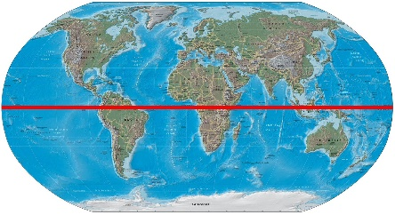

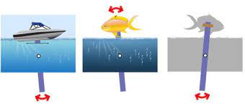
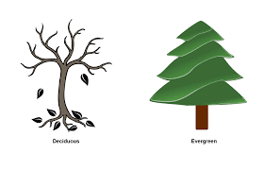

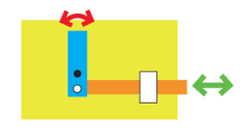
RE – Why does Christmas matter to Christians?

PE Year 1– Multi-skills
Agility Balance Coordination

Celebrations Christmas
Gospel New Testament
Nativity Thankful
Jesus Nazareth
Advent Bethlehem
Tradition
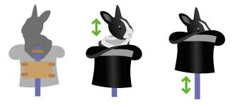
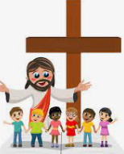

PE Year 2 – Dance
Actions Dynamic Space

Get
Heartsmart

HeartSmart these famous explorers? Where did they go? What did they do?

