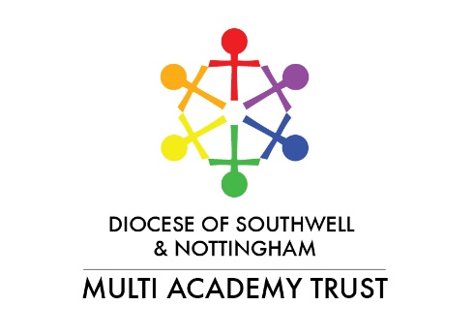
Press Release 23rd September 2019
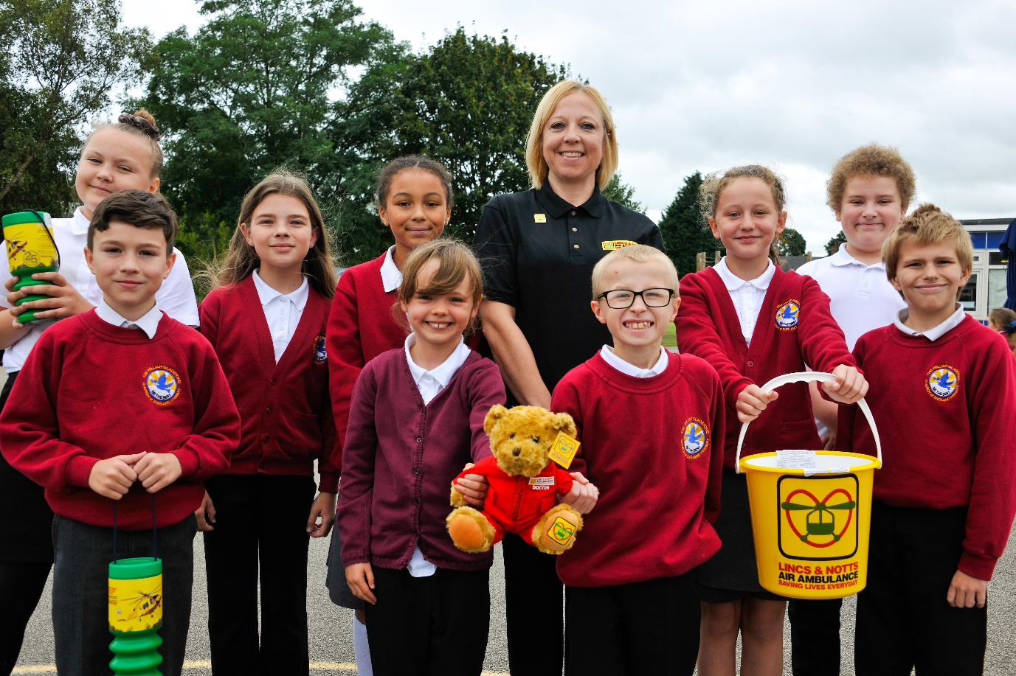
Photograph: William Gladstone CE Primary Academy pupils are going to support their real-life heroes, the Lincs & Notts Air Ambulance
Lincs and Notts Air Ambulance visit William Gladstone C of E Primary Academy
William Gladstone Church of England Academy in Newark welcomed a visit from Heather Rabett of the Lincs & Notts Air Ambulance to explore ways in which the school can provide support to the charity, and also for children to gain inspiration and insight about the occupations needed to keep the lifesaving crew operational.
During a week where children explored the topic of heroes, Heather was able to discuss the work of the real-life heroes who take to the skies to help in medical emergencies.
Heather said, “I have been invited along to talk to children about our service and also to raise children’s aspirations in terms of careers by looking at our air crew, the doctors and paramedics, and the ground crew and charity teams as well. I have talked to children about how we all work together to raise enough funds to keep the helicopter in the sky. Everything we do is about keeping our service going because we don’t receive any public funding whatsoever, and everything we do is funded by donations from the public and businesses.”
Head Teacher at the school is Sarah Clarke who said, “We want to inspire our children to look at the variety of careers and skills that will equip them for their future careers and were delighted to welcome Heather to talk about the amazing work the Air Ambulance carry out daily. These real-life heroes are a great source of inspiration for our children who have gained an understanding of the different professions needed to help them to carry out their lifesaving work.
“We will use the visit as a source for further work looking at different careers and the children will be looking at some inventive ways that we can support the work of the air ambulance going forward.”

ENDS
Not for publication:
For press enquiries about The William Gladstone Church of England Primary Academy, Newark, call Louise Brimble at By Appointment PR on 07808 596244.
Note to Editors:
- To find out more about The William Gladstone Church of England Primary Academy, please follow the link: http://www.williamgladstonecofe.com/
- William Gladstone Church of England Primary Academy is part of the Diocese of Southwell & Nottingham Multi-Academy Trust. For more information, please follow the link: http://www.snmat.org.uk/index.html
- All photographs are available to print with full permissions. Authorised for general release.

